CPCS – Community pharmacy UTI and infected eczema / insect bites September 2022
At Stourport Medical Centre (SMC) patients may be directed to contact Stourport Pharmacy or other pharmacy offering the service by care coordinators with the following conditions:
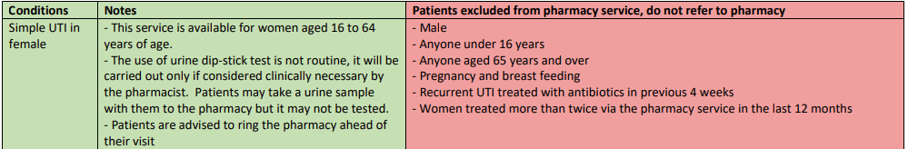
Simple UTI in female |  | - Allergy to nitrofurantoin  - Chronic kidney disease  - Kidney pain  - Has a catheter
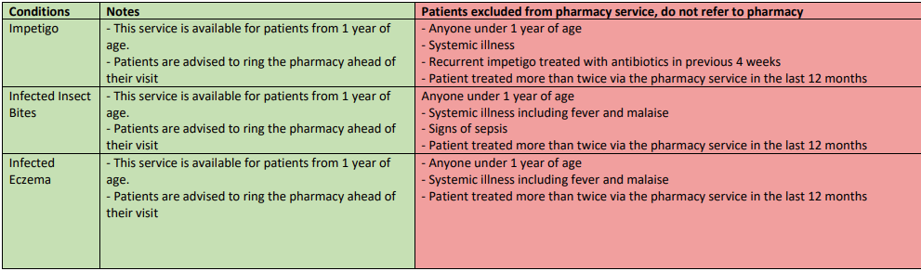
Patients must meet the inclusion criteria and none of the exclusion criteria. The service will rely on capacity at Stourport pharmacy and patients must contact Stourport pharmacy first either by phone or if they are already in the building they are able to be seen directly. If patients cannot be treated at the pharmacy they will be redirected to SMC.

